Chapter 5, Solution 30.

In the circuit shown in Fig. 5.68, find i_{x} and the power absorbed by the 20-kΩ resistor.

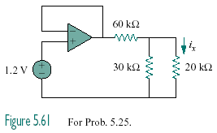

Figure 5.68
For Prob. 5.30.

Solution

The output of the voltage becomes

v_{o} = v_{i} = 1.2 V

By voltage division,

10μA

2μW.

